##### Universal Institute of Engineering and Technology (UIET) Mohali, PUNJAB

**Six Months Training Report on**

##### Car Rental System At

**Solitaire Infosys Pvt. Ltd.**

**A FULL STACK DEVELOPMENT WITH PHP TRAINING CUM PROJECT REPORT SUBMITTED IN PARTIAL FULFILLMENT OF THE REQUIREMENTS FOR THE DEGREE OF**

##### Bachelor of Technology in

**Computer Science & Engineering At**

##### I. K. Gujral Punjab Technical University Jalandhar



**Submitted by:- Pankaj Kumar Submitted to:- Er. Preeti**

##### Sondhi

**Roll. No. :-1810718**

##### Course :-B. Tech(CSE)

**Semester :- 8TH**



# CANDIDATE’S DECLARATION

*I, Pankaj Kumar, bearing roll no. 1810718, a student of B. Tech in Computer Science & Engineering department hereby declare that I own the full responsibility for the information, results etc. provided in this Training Report titled “Car Rental System” submitted to Universal Institute of Engineering and Technology for the award of*

*B. Tech (CSE) degree. I have taken care in all respect to honour the intellectual property right and have acknowledged the contribution of others for using them in academic purpose and further declare that in case of any violation of intellectual property right or copyright I, as a candidate, will be fully responsible for the same. My supervisor should not be held responsible for full or partial violation of copyright or intellectual property right.*

*Signature Of Candidate*

*Pankaj Kumar*

# CERTIFICATE

*This is to certify that this report represents the original work done by* ***PANKAJ KUMAR*** *during this project submission as a partial fulfillment of the requirement for the Car Rental system project of Computer Science Engineering, 8th semester, Universal Group Of Institution, Lalru, Mohali.*

**ACKNOWLEDGEMENTS**

*It is my pleasure to be indebted to various people, who directly or indirectly contributed in the development of this work and who influenced our thinking, behavior, and acts during the course of our training.*

*I express my sincere gratitude Ms. Preeti Sondhi****,*** *worthy mentor, guide and a great teacher who influenced and inspired me in many ways.*

*Lastly, I would like to thank the almighty and my parents for their moral support and my friends with whom I shared our day-to-day experience and received lots of suggestions that improved our quality of work.*

**Table Of Contents**

**Contents…………………....................Page No.**

1. Abstract 7
2. Introduction 8
3. Car Rental Services 10
4. Functional & Non-Functional Requirements 11
5. Data Flow Diagrams 13
6. Use Case Diagrams 15
7. Activity Diagrams 18
8. Introduction Of Technologies

Used In Project 26

1. Snapshots 32
2. Conclusion… 39

**Abstract of Car Rental System**

The car rental is being developed for customers o that they can book their vehicles from any part of the world. This application takes information from the customers through filling their details. A customer being registered in the website has the facility to book a vehicle which he requires.

The proposed system is completely integrated online systems. This automated system facilitates customer and provides to fill up the details according to their requirements. It includes type of vehicle they are trying to hire and location. The purpose of this system is to develop a website for the people who can book their vehicles along with requirements from any part of the world.

**INTRODUCTION TO ONLINE CAR RENTAL SYSTEM**

#### Introduction

This project is designed so as to be used by Car Rental Company specializing in renting cars to customers. It is an online system through which customers can view available cars, register, view profile and book car.

#### Reason for the Project

The advancement in Information Technology and internet penetration has greatly enhanced various business processes and communication between companies (services provider) and their customers of which car rental industry is not left out. This E-Car Rental System is developed to provide the following services:

* Enhance Business Processes: To be able to use internet technology to project the rental company to the global world instead of limiting their services to their local domain alone, thus increase their return on investment (ROI).
* Online Vehicle Reservation: A tools through which customers can reserve available cars online prior to their expected pick-up date or time.
* Customer’s registration: A registration portal to hold customer’s details, monitor their transaction and used same to offer better and improve services to them.
* Group bookings: Allows the customer to book space for a group in the case of weddings or corporate meetings (Event management).

#### Problem Statement

A car rental is a vehicle that can be used temporarily for a fee during a specified period. Getting a rental car helps people get around despite the fact they do not have access to their own personal vehicle or don't own a vehicle at all. The individual who needs a car must contact a rental car company and contract out for a vehicle. This system increases customer retention and simplify vehicle and staff management.

#### Aims & Objectives

* To produce a web-based system that allow customer to register and reserve car online and for the company to effectively manage their car rental business.
* To ease customer’s task whenever they need to rent a car.

#### Scope

This project traverses a lot of areas ranging from business concept to computing field, and required to perform several researches to be able to achieve the project objectives. The area covers include:

* Car rental industry: This includes study on how the car rental business is being done, process involved and opportunity that exist for improvement.
* PHP Technology used for the development of the application.
* General customers as well as the company’s staff will be able to use the system effectively.
* Web-platform means that the system will be available for access 24/7 except when there is a temporary server issue which is expected to be minimal.

## CAR RENTAL SERVICES

#### How Car Rental Services Work

A car rental is a vehicle that can be used temporarily for a period of time with a fee. Renting a car assists people to get around even when they do not have access to their own personal vehicle or don't own a vehicle at all. The individual who want to rent a car must first contact the car rental company for the desire vehicle. This can be done online. At this point, this person has to supply some information such as; dates of rental, and type of car. After these details are worked out, the individual renting the car must present a valid Identification Card.

Most companies throughout the industry make a profit based of the type of cars that are rented. The rental cars are categorized into economy, compact, compact premium, premium and luxury. And customers are free to choose any car of their choice based on their purse and availability of such car at the time of reservation.

#### Benefits of Online Car Rental Services

* This online car rental solution is fully functional and flexible.
* It is very easy to use.
* This online car rental system helps in back office administration by streamlining and standardizing the procedures.
* It saves a lot of time, money and labour.
* Eco-friendly: The monitoring of the vehicle activity and the overall business becomes easy and includes the least of paper work.
* The software acts as an office that is open 24/7.
* It increases the efficiency of the management at offering quality services to the customers.
* It provides custom features development and support with the software.

**FUNCTIONAL AND NON-FUNCTIONAL REQUIREMENTS**

#### Functional Requirements

Requirement analysis is a software engineering technique that is composed of the various tasks that determine the needs or conditions that are to be met for a new or altered product, taking into consideration the possible conflicting requirements of the various users.

Functional requirements are those requirements that are used to illustrate the internal working nature of the system, the description of the system, and explanation of each subsystem. It consists of what task the system should perform, the processes involved, which data should the system holds and the interfaces with the user. The functional requirements identified are:

1. Customer’s registration: The system should allow new users to register online and generate membership card.
2. Online reservation of cars: Customers should be able to use the system to make booking and online reservation.
3. Automatic update to database once reservation is made or new customer registered: Whenever there’s new reservation or new registration, the system should be able update the database without any additional efforts from the admin.
4. Feedbacks to customers: It should provide means for customers to leave feedback.

#### Non-Functional Requirements

It describes aspects of the system that are concerned with how the system provides the functional requirements. They are:

1. Security**:** The subsystem should provide a high level of security and integrity of the data held by the system, only authorized personnel of the company can gain access to the company’s secured page on the system; and only users with valid password and username can login to view user’s page.
2. Performance and Response time: The system should have high performance rate when executing user’s input and should be able to provide feedback or response within a short time span usually 50 seconds for highly complicated task and 20 to 25 seconds for less complicated task.
3. Error handling: Error should be considerably minimized and an appropriate error message that guides the user to recover from an error should be provided. Validation of user’s input is highly essential. Also the standard time taken to recover from an error should be 15 to 20 seconds.
4. Availability: This system should always be available for access at 24 hours, 7 days a week. Also in the occurrence of any major system malfunctioning, the system should be available in 1 to 2 working days, so that the business process is not severely affected.
5. Ease of use: Considered the level of knowledge possessed by the users of this system, a simple but quality user interface should be developed to make it easy to understand and required less training.

### DATA FLOW DIAGRAMS

#### Data Flow Diagram (DFD)

A Data Flow Diagram (DFD) is a graphical representation that depicts the information flow and the transforms that are applied as data moves from input to output.

Figur

EMAIL FOR RESERVED CAR CAR RESERVED



RESERVE A CAR

EMAIL FOR RESERVED CAR

NEW

CUSTOMER

RENTAL

ADD

CAR RENTAL COMPANY

REGISTRATION

ONLINE CAR CUSTOMER

~~LOGIN REQUEST~~ . SYSTEM

AUTHENTICATION

TRANSACTION REPORTS

REGISTRATION CONFIRMATION

Figure: Level 0 DFD of Online Car Rental System In this diagram, Customer and Car Rental Company are the two entity sets.

Functions of Customer:

* New Registration
* Login Request
* Registration Confirmation by the System
* Reserve Car
* Car Issued by the System • Email received for Reserved Car Functions of Car Rental Company:
* Add Customer
* Send E-Mails for Reserved Car • View Transaction reports

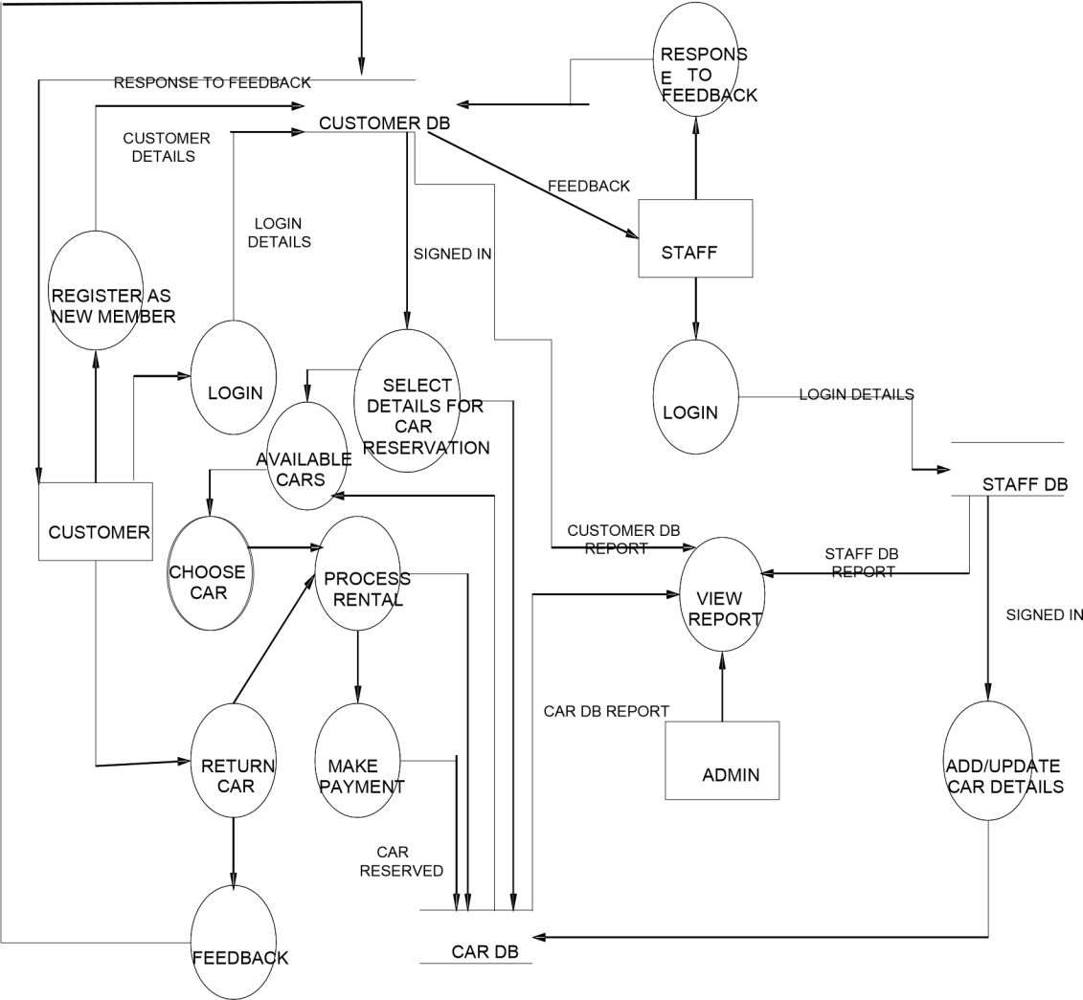

Figure: Level 1 DFD of Online Car Rental System

### USE-CASE DIAGRAMS

#### Actor and Use Case Description

Actor and use case description shows the detail description of interaction between the actors and their use cases. The description enables to have a proper understanding of how actor interacts with the system through their use cases.

|  |  |  |  |
| --- | --- | --- | --- |
| **Actor** | **Use Case** | | **Use Case Description** |
| Customer | Register member | as | This use case describes the activities of the customer to register online and become a member. Customer's details are required as part of the registration. Login detail is automatically sent to the customer after successful registration. |
| Make reservation | | This use case enable customer to search and make reservation. Non-register customer will be directed to register before their reservation can be confirmed. Notification is automatically send to the customer after the task is completed. |
| Return car | | This use case describes the event of customer returning the car borrowed, the use case extends "process rental" use case from the staff actor. |
| Give feedback | | This use case is used by the customer to provide feedbacks/comment to the company; a confirmation notification will be send to the customer once a feedback has been submitted. |

|  |  |  |
| --- | --- | --- |
| Staff | Add new car | This use case is used by the staff to add new car to the company's fleet database. Staff will need to login to activate this use case. |
| Update car details | This use case is used by the staff to edit and modify  car details whenever there is new renewal (insurance, road tax). It allows the company to keep |
|  |  | up-to-date record of their fleet. |
| Reply to  customer’s feedback | This use case describes the event by which staff sends reply to customer's earlier feedback. It depends on  `give feedback' use case from the customer. |
| Process rental | This use case described the event by which staff updates the system when customer pick up or when returning car. |
| Admin | Add new staff | This use case describes the event by which Admin add new staff detail to the company's staff database.  It is invoke whenever a new staff join the company. |
| View report | This use case is used by the Admin to view transaction report. |

Table: Actors and Use Case Description

#### Use Case Diagram



Register as member

Add new car

Staff

Update car details

Customer

Make reservation

<<extend>>

~~P~~rocess rental

Reply to

Return car

Give feedback/

comments

customer's

feedback

Admin

View report

Figure: E-Car Rental System [use case]

#### Use-Case Dependency Diagram

Make reservation

Register as Member

Depends on

Add new car

Update car details

Pick car

<<extend>>

<<extend>> Process rental

Return car

<<extend>> <<extend>>

Late return

Early return

Reply to customer's feedback

Depends on

Give feedback/ comments

Figure: Use Case Dependency Diagram

<<include>>

View report

View cus tomer's patronage

<<include>>

View transaction report

### ACTIVITY DIAGRAMS

#### Activity Diagram

Activity diagrams graphically represent the sequential business and operational workflows of a system. It is a dynamic diagram that shows the activity and the event that causes the object to be in the particular state. The workflows from activity diagram will serve as guide for system navigation in the final design phase of the system. **6.1.1**

##### Member Registration



Customer

Start

E-Car Rental System

[Yes]

Enter username and

password

Accept terms & conditions

[No]

Username exist?

Confirm and submit

Display customer's

welcome screen

Send email confirmation

End

Enter details

Figure : Register as member

##### Profile Modification



Customer

Start

E-Car Rental System

[No]

Login

Valid?

Navigate to Edit

Profile

[Yes]

Confirm and submit

Update database

Send confirmation

notification

Log out

End

Modify your profile

Figure: Modify profile

##### Reservation of Car



Customer

E-Car Rental System

Start

Choose pickup

location

Choose pick up date

and time

Choose return location

Choose return date and time

Choose vehicle class

Choose from

available car

Display available

cars

[No]

Member?

Login

Register

[No]

Valid?

[Yes]

merge

Redirect to payment gateway

Send confirmation

End

Confirm

Figure: Make Reservation

##### Customer Feedback



Customer

Start

E-Car Rental System

Enter your details

Submit feedback

Send notification

End

Enter your message/remark

Figure: Give feedback/comment

##### Payment of Car Rent

Staff

Start



~~Provide member id~~

[Yes]

Pay late charges

Check rental detail

Merge

Overdue?

[No]

Confirm return

~~Update database~~

Figure: Rent a Car

End

##### Adding a New Car



Staff

Login

E-Car Rental System

[No]

Login

Valid?

[Yes]

Enter car details

Add to inventory

Update status

End

Figure: Add a New Car

##### View Report



Admin

E-Car Rental System

Start

Login

[No]

Valid?

Specify report to view

[Yes]

Confirm and submit

Retrieve report

End

Figure: View report

### INTRODUCTION OF TECHNOLOGIES USED IN PROJECT

#### About PHP

**PHP: Hypertext Pre-processor** is a widely used, general-purpose scripting language that was originally designed for web development to produce dynamic web pages. For this purpose, PHP code is embedded into the HTML source document and interpreted by a web server with a PHP processor module, which generates the web page document.

As a general-purpose programming language, PHP code is processed by an interpreter application in command-line mode performing desired operating system operations and producing program output on its standard output channel. It may also function as a graphical application. PHP is available as a processor for most modern web servers and as standalone interpreter on most operating systems and computing platforms.

PHP was originally created by Rasmus Lerdorf in 1995 and has been in continuous development ever since. The main implementation of PHP is now produced by the PHP Group and serves as the *de facto* standard for PHP as there is no formal specification. PHP is free software released under the PHP License.

PHP is a general-purpose scripting language that is especially suited to server-side web development where PHP generally runs on a web server. Any PHP code in a requested file is executed by the PHP runtime, usually to create dynamic web page content. It can also be used for command-line scripting and client-side GUI applications. PHP can be deployed on most web servers, many operating systems and platforms, and can be used with many relational database management systems. It is available free of charge, and the PHP Group provides the complete source code for users to build, customize and extend for their own use.

Originally designed to create dynamic web pages, PHP now focuses mainly on serverside scripting, and it is similar to other server-side scripting languages that provide dynamic content from a web server to a client, such as Microsoft's Active Server Pages, Sun Microsystems’ Java Server Pages, and mod_perl. PHP has also attracted the development of many frameworks that provide building blocks and a design structure to promote rapid application development (RAD). Some of these include CakePHP, Symfony, CodeIgniter and Zend Framework, offering features similar to other web application frameworks.

###### PHP Syntax:

HTML and PHP code is written on the same page, and to distinguish PHP code from HTML, the PHP code is enclosed within <? php ?> Tags.

For example:

<html>

<head><title>php basics</title></head>

<body>

<h2>HELLO</h1>

<?php

echo "hello";

?>

</body>

</html>

In the above example PHP code is embedded within HTML. In this way PHP and HTML coding is combined on the same page.

Since PHP is a server side scripting language, the PHP coding cannot be seen by the end user through view source option, due to this feature PHP is very secure.

PHP is a parsed language; therefore PHP environment is necessary at the server for running PHP scripts.

###### Working of PHP:

Figure : Working of PHP

When a client requests web page containing PHP code from the server, then the requested PHP pages are parsed under PHP environment and interaction with database is made if required.

After server side processing, the resulting HTML pages are passed to client and displayed on the browser.

In this way the working of php is complete.

#### Connecting PHP Application to MySQL Database

1. Make a connection variable to the database:

$con= mysql_connect ("localhost","servername","password"); Here $con is a connection variable to database.

1. Select a database over that connection variable:

$db=mysql_select_db("databasename",$con);

1. Prepare a sql query to execute:

$qry= Select * from abc;

1. Run the sql query:

$result=mysql_query($qry);

1. Iterate over the result:

while($row = mysql_fetch_array($result))

{

//some logic

}

#### Introduction to MySQL:

**MySQL** is a relational database management system (RDBMS) that runs as a server providing multi-user access to a number of databases. MySQL is officially pronounced

("My S-Q-L"), but is often pronounced ("My Sequel"). It is named for original developer Michael Widenius's daughter My.

The MySQL development project has made its source code available under the terms of the GNU General Public License, as well as under a variety of proprietary agreements. MySQL is owned and sponsored by a single for-profit firm, the Swedish company MySQL AB, now owned by Sun Microsystems, a subsidiary of Oracle Corporation.

MySQL code uses C and C++. The SQL parser uses yacc and a home-brewed lexer, sql_lex.cc.

MySQL works on many different system platforms, including AIX, BSDi, FreeBSD, HPUX, i5/OS, Linux, Mac OS X, NetBSD, Novell NetWare, OpenBSD, OpenSolaris, eComStation, OS/2 Warp, QNX, IRIX, Solaris, Symbian, SunOS, SCO OpenServer, SCO UnixWare, Sanos, Tru64 and Microsoft Windows. A port of MySQL to OpenVMS also exists.

All major programming languages with language-specific APIs include Libraries for accessing MySQL database. In addition, an ODBC interface called MyODBC allows additional programming languages that support the ODBC interface to communicate with a MySQL database, such as ASP or ColdFusion. The HTSQL - URL based query method also ships with MySQL adapter allowing direct interaction with MySQL database from any web client via structured URLs. The MySQL server and official libraries are mostly implemented in ANSI C/ANSI C++.

#### Introduction to APACHE SERVER:

In this project apache server is used to parse and execute PHP pages, before deploying websites on the server, the website should be tested at the developer side to get a feel of how the website will work on actual server.

Therefore apache server is like a local server on the developer side, apache server should be informed about the environment on which it should work.

In our project apache server is configured to work with PHP, in this way all the PHP pages are parsed and executed by the server.

When apache is installed on the system, then its services is controlled by apache service monitor.

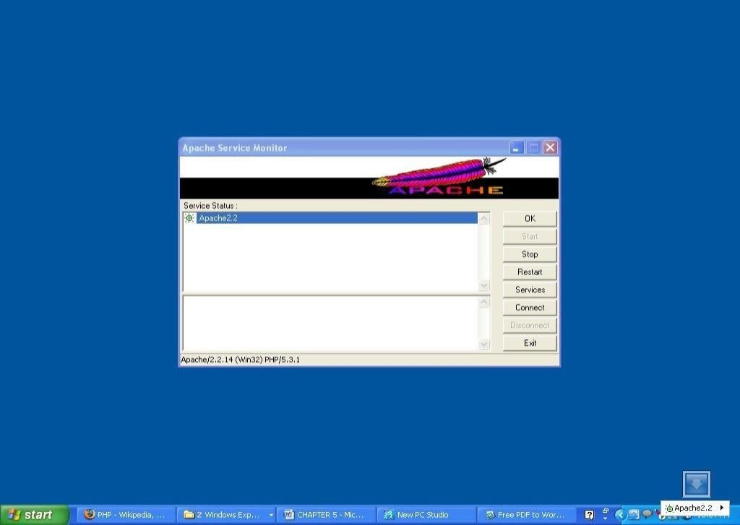

Figure : APACHE Service Monitor

### SNAPSHOTS

#### SNAPSHOT 1 : HOMEPAGE

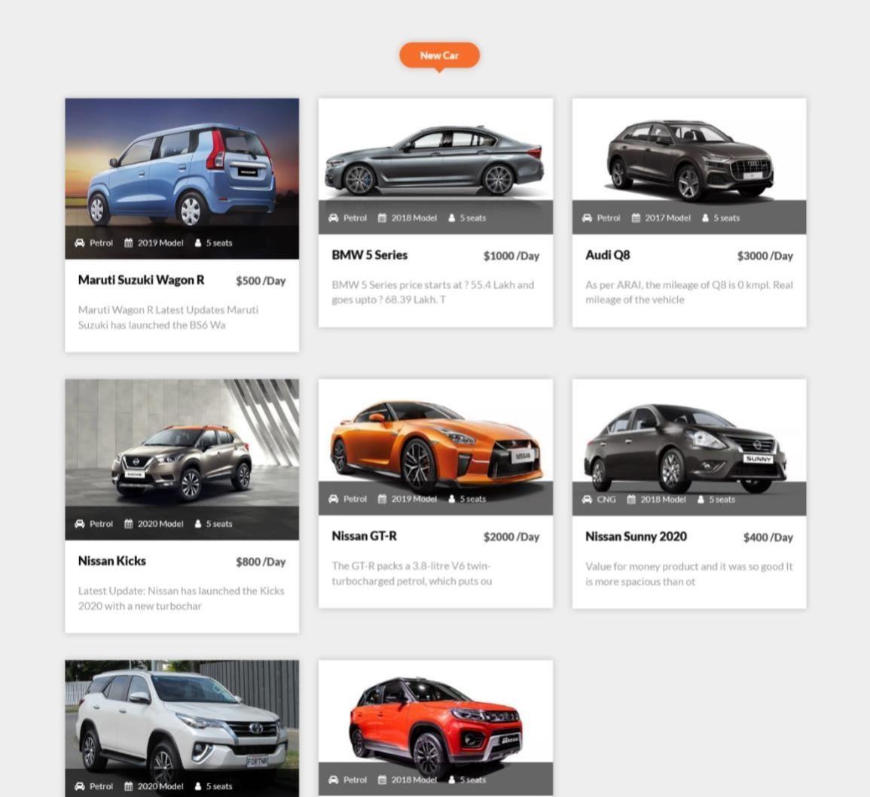

**SNAPSHOT 2: CAR CATALOGUE**

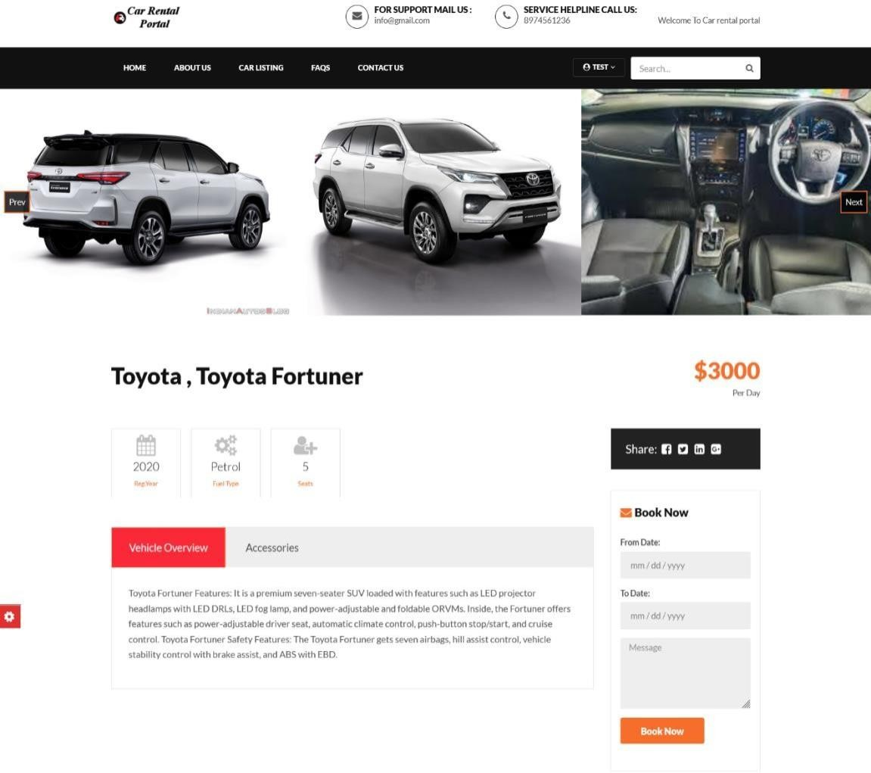

#### SNAPSHOT 3: CAR DETAILS

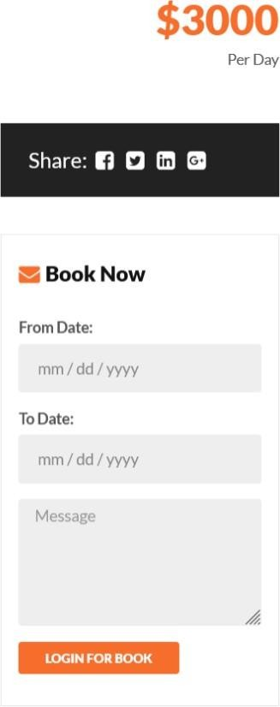 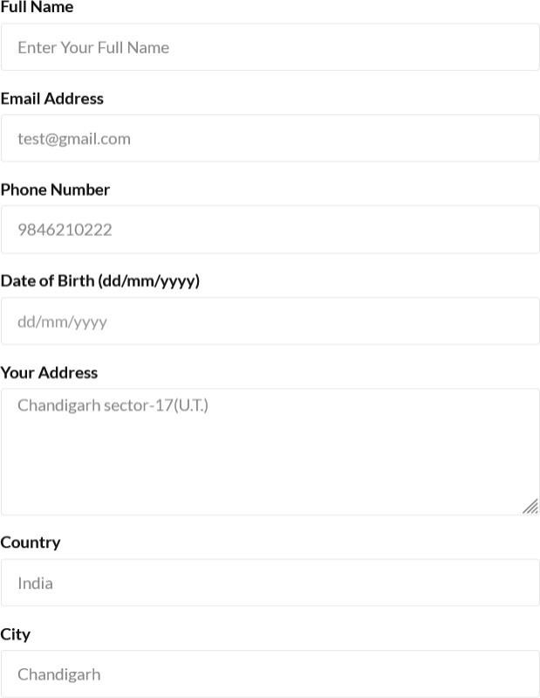

#### SNAPSHOT 4: CAR BOOKING

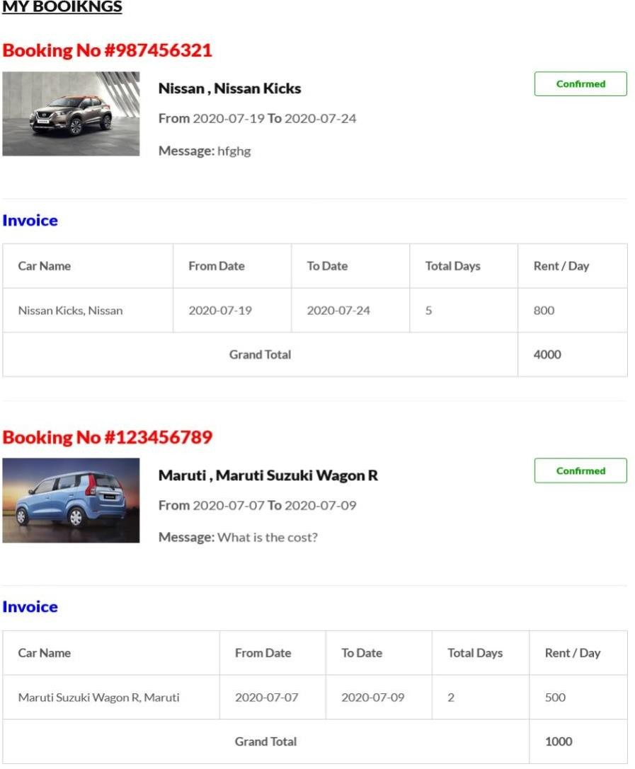

**SNAPSHOT 5: BOOKING DETAILS**

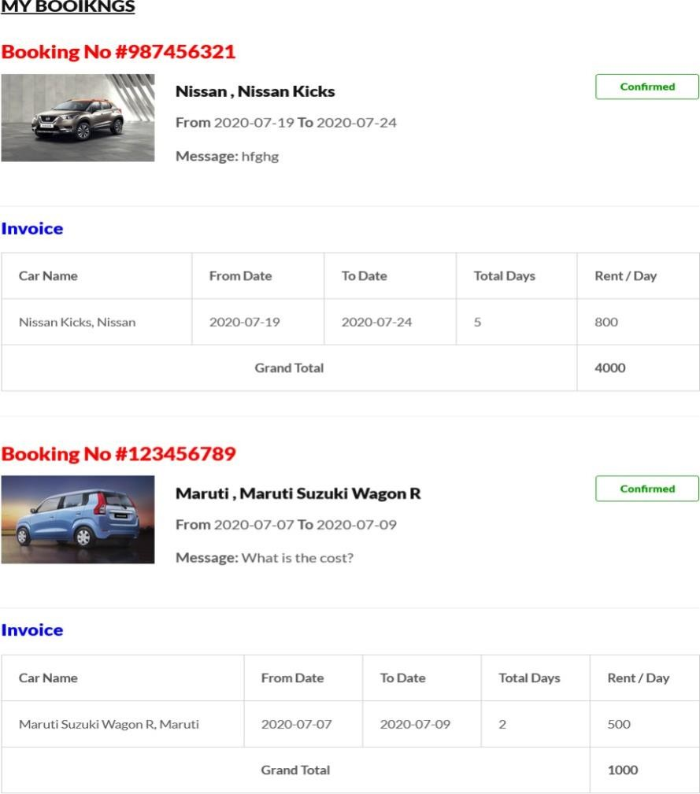

#### SNAPSHOT 6: PAYMENT PAGE.

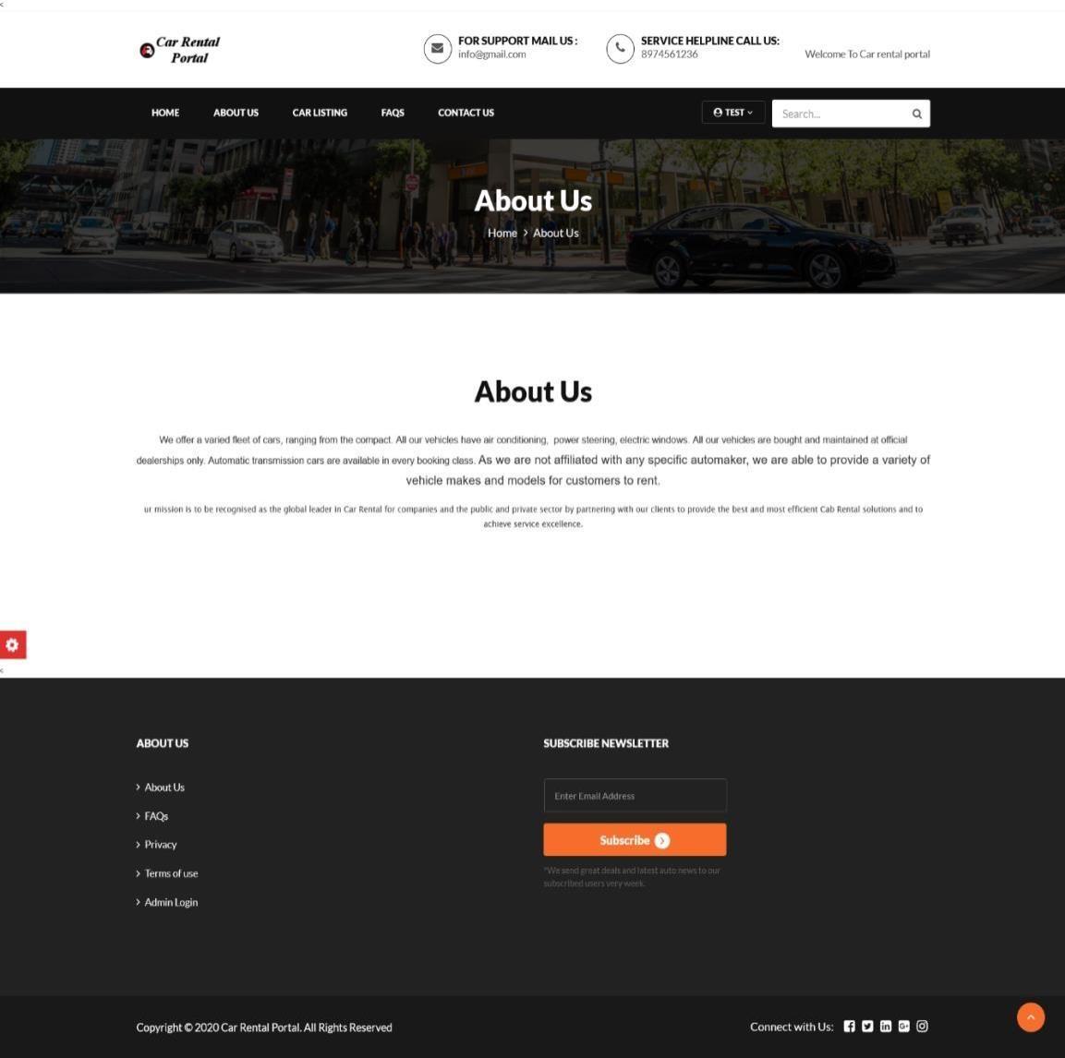

**SNAPSHOT 7: ABOUT US**

### CONCLUSION

Car rental business has emerged with a new goodies compared to the past experience where every activity concerning car rental business is limited to a physical location only. Even though the physical location has not been totally eradicated; the nature of functions and how these functions are achieved has been reshaped by the power of internet. Nowadays, customers can reserve cars online, rent car online, and have the car brought to their door step once the customer is a registered member or go to the office to pick the car.

The web based car rental system has offered an advantage to both customers as well as Car Rental Company to efficiently and effectively manage the business and satisfies customers’ need at the click of a button.